<https://onlinegdb.com/4tVJCPEtA>

For –Each Loop for 2-D Jaggaed Array

Limitations of For Each Loop :

* We cannot access /Modify through indexes.
* Traverse /Iterate in only Forward direction

Printing the data in Reverse using For Loop

<https://onlinegdb.com/dpA_z06D_>

Alternate data printing in Loop:

<https://onlinegdb.com/hok0V3KzX>

int[] ar=new int[4];

Int[][] ar=new int[2][2]

Int ar [][] =new int[2][2]

Int [][] ar=new int[2][2]

Int[][] ar=new int[2][2]

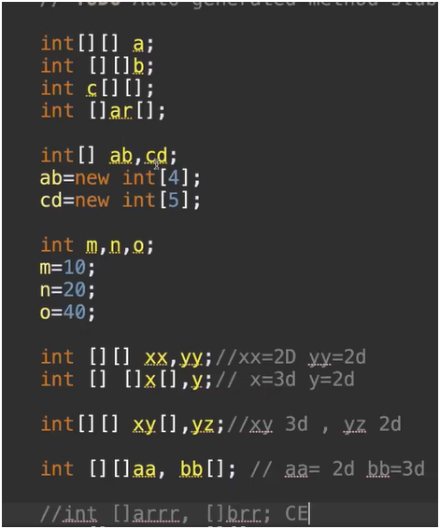

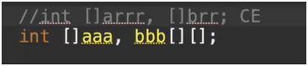

Array can store both Primitive and Objects whereas

Collections can store only Objects.

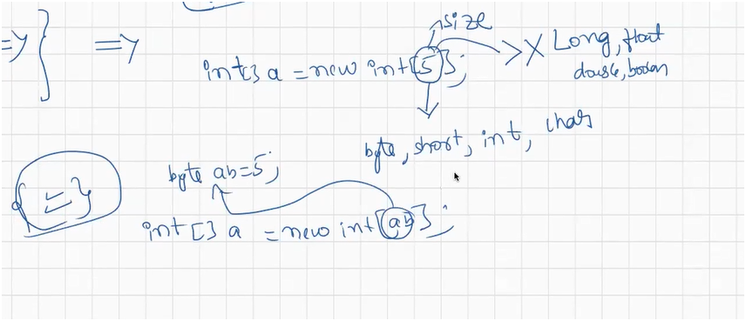

The Size which we mention can be any of the byte,short,int,char

But it cannot be long,float,double,boolean.

Int a[]=new int[a]; ----->int a[]=new int[97];

Expection :

During Runtime Program will terminate and raises and Exception.

java.lang.NegativeArraySizeException:

<https://onlinegdb.com/wYff0Q4iP>

java.lang.OutOfMemoryError:

<https://onlinegdb.com/CfUY8KYqF>

Every type of Array will have class.

If we try to create the Object for Class that is not present it would result in Error.

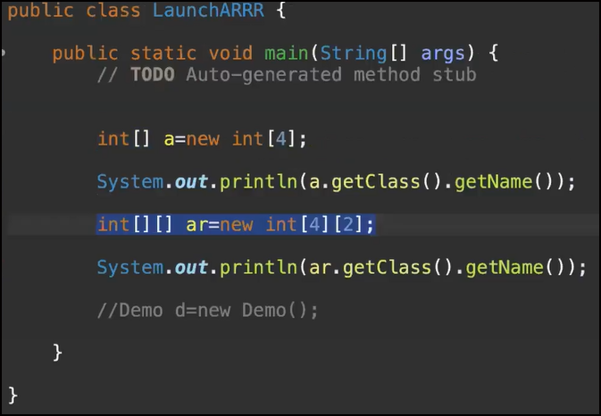 But this Class will not be available for Programmers.

We have Array Class which is pre-defined. We can perform the operations as like how we will do Manually.

Sort()

Fill()

Binary Search()

All these methods are static .

If a method is static then we can call that methods using class name

Arrays.sort()

There will be no issue if we create an Object and access this static method with that Object.

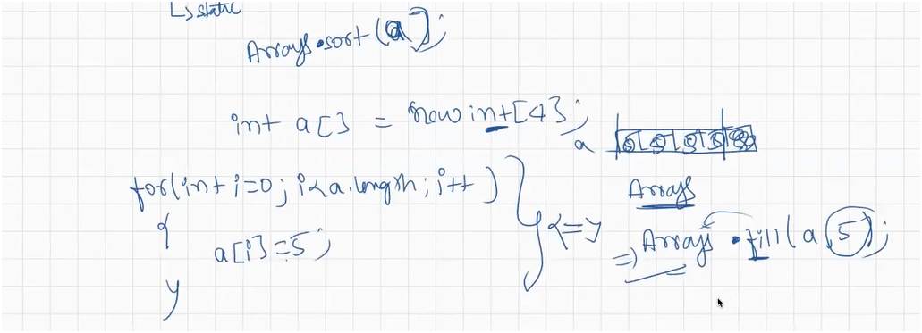

Default value of int in array is 0

int a[]=new int [4]

Array will be created with 0 value .If we want all the values to be filled with same value then we can fill in the below format.

Array.fill(a,10)

Now Array will be filled with value 10 in all the locations



Arrays.sort(a);

Sum of Elements of Array :

<https://onlinegdb.com/kwTwovL9R>

Max and Mix of Array:

<https://onlinegdb.com/e1kAAQ1KJf>

Linear Search: